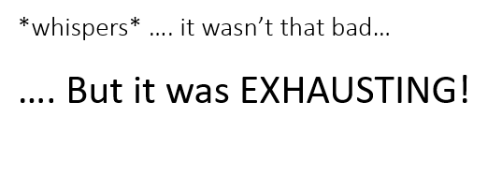
,601 views
Ms Evans EngTwit
@MissEvsEngTwit

Nov 8th 2019, 17 tweets, 6 min read
So following our recent Ofsted inspection under the new framework, several people have asked me to share my "deep dive" experiences as a HOD of English. Here are the slides I shared with English teachers across our trust this afternoon:
2: Genuinely, it wasn't that bad - I *may* have even enjoyed some parts. If someone wants to know about my department, then I want to be the one to tell them about it. However, it did involve over five hours with an Inspector. Be prepared for a loooong couple of days!
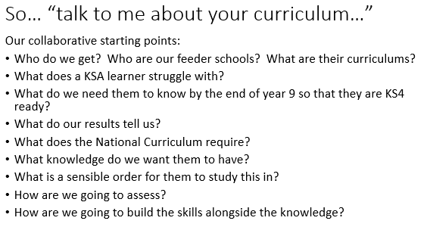
3: Inspector Q1: So. tell me about your curriculum. And I could, as my team and I had spent the summer term redesigning our KS3. Our starting point were the Qs below and we discussed it at length and planned collaboratively
4: I had a simple, single sheet of A4 which mapped out the curriculum for 7,8 and 9. I could point out where knowledge was built upon across and between years. I could show the increasing challenge of the assessment tasks. I could talk through how the NC was covered in full.
5: I also showed our unit learning journeys and our "know it, say it, prove it, link it" approach. I was very clear that these were a starting point and would be reviewed across the year.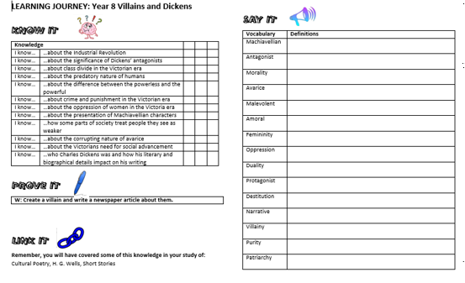

6: Why was this useful? Well compare below the questions we asked ourselves when deciding upon the units and (some of) the follow up questions asked by the inspector...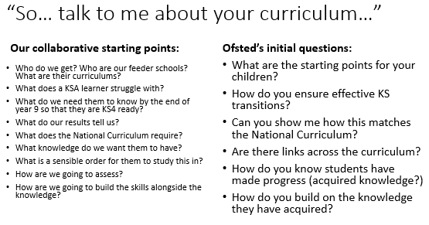

7: So... what will I see in your classroom? They selected 6 lessons to see in the 2 hour slot but then wandered into more. Lots of time talking to students.
TopTip! Have class lists ready so you can make a note of who they speak to as they will want to meet them again later...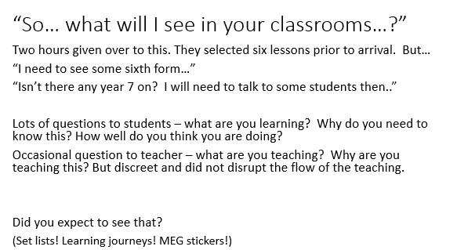

8: The Learning journey sheets were invaluable in the lesson obs. The explicit vocab teaching was clear - and it meant students didn't clam up when asked about the knowledge they didn't have before starting the unit that they did now.

9: "So what will we see in your books". This was another full hour and was very detailed. They wanted to the books of every child they spoke to in lessons and from year groups that we didn't see. See the sort of Qs below.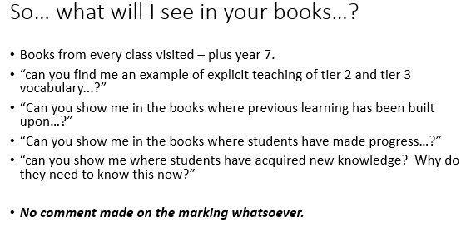
10: I cannot stress this enough. THERE WAS NOT A SINGLE COMMENT ON FREQUENCY OR QUALITY OF MARKING. NOT ONE. I did, however, use teacher feedback and DIRT tasks to evidence where misconceptions had been identified and progress made.

11: "So what do your students think?"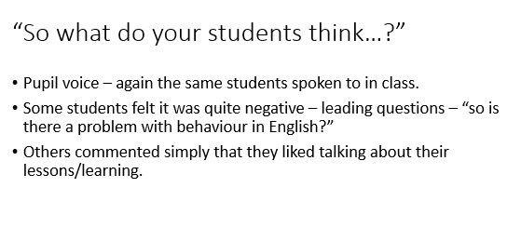
12: They met with all of my staff without me. It was a reminder that, although I had been through many an Inspection meeting, this was the first time that my young had spoken with an Inspector. It was daunting! But they knew their stuff - because they had helped plan it!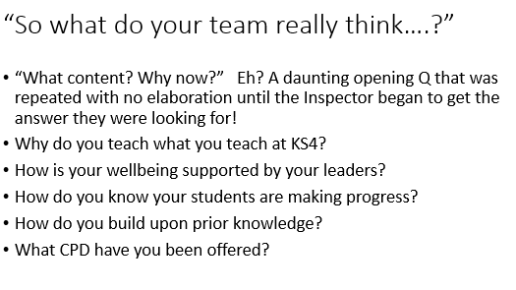
13: And breathe... looking back I cannot stress enough how important a cohesive team is. I couldn't teach any of my lessons that first day and my colleagues covered lessons, fetched books, fetched students, dealt with behaviour, etc. It was a real team effort.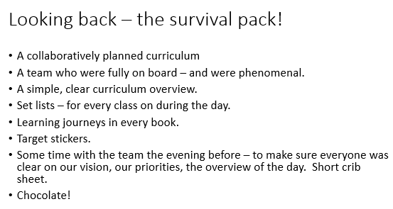
14: So what next? Obviously our new curriculum is in its infancy. This wasn't done "for Ofsted" it was done because it is right for our students and so, as a dept, our next steps are as follows..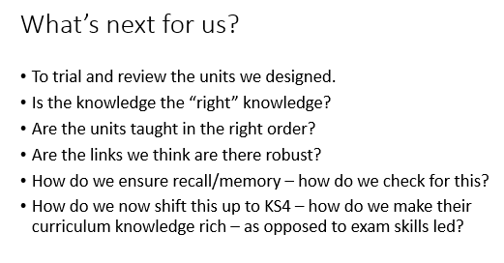

15: And that was that. No feedback as such and no joint meetings with my line manager. I *think* it went ok. Either way, you may find this info useful. However, every experience is different - even across depts in our school.
Have a good weekend!
You can tell I'm a twitter novice. I forgot the hashtags! #Englishdeepdive #EnglishHOD #edutwitter #deepdiveexperience #curriculum Um. any others? Please add or share if you think it will be useful!

My young?? I meant my young team!!

